### **Foundation**

**Species**

|  |  |
| --- | --- |
| Coffea Arabica | Coffea Canephora (Robusta) |
| * Cultivated in mountainous regions above 800 meters * Lower yields * Less tolerant of hot temperatures, pests, and diseases | * Cultivated in lowland regions below 800 meters * Higher yields, up to 50% more * More resistant to hot temperatures, pests, and diseases |

C. arabica and C. canephora are the two main species traded commercially.

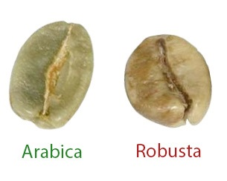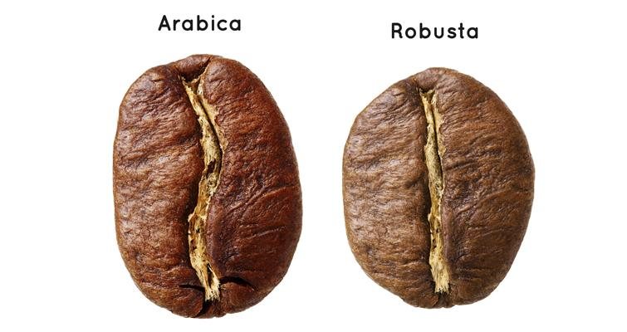

**Geography**

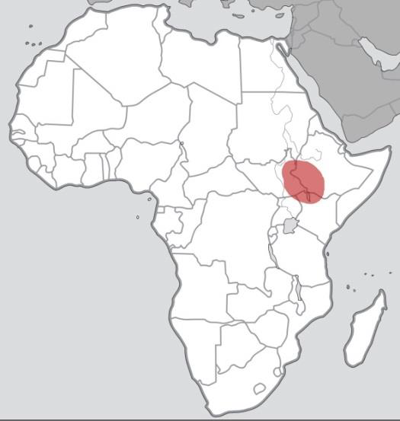 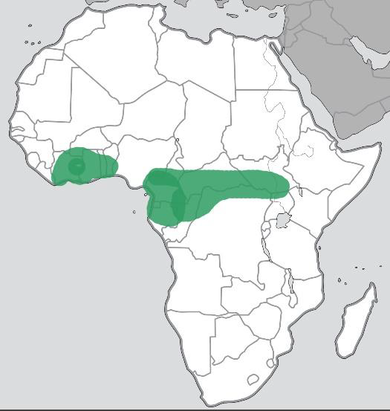

Africa is the birthplace of coffee. C. arabica originated in East Africa (Ethiopia) while C. canephora traces back to Central and West Africa.

The “coffee belt” is the region around the equator suitable for coffee cultivation.

The areas around the Tropics of Cancer and Capricorn have the ideal tropical climate.

**Varieties**

* Typica and Bourbon are two significant varieties of C. arabica
* Cultivars are created by selective breeding
* Hybrids contain genetic material from both C. arabica and C. canephora

**Climate Risks**

Can lead to reduced yields:

* Rising Temperatures - leading to rapid spread of leaf rust (roya)
* Severe Frost
* Drought
* Erratic Rain Patterns

**Global Production**

Roughly ________ % Arabica and ________ % Robusta.

International Coffee Organization (ICO) data is listed in millions of 60Kg bags.

Coffee production yields have been steadily increasing.

_______________ is the #1 producer of natural Arabica, and #1 overall

_______________ is the #1 producer of washed Arabica and #2 overall

_______________ is the #1 producer of Robusta

**Farming**

* Smallholders own or rent a few hectares and rely on _____________ ___________
* Cooperatives (co-ops) are made up of many smallholders and provide processing equipment and other resources
* Smallholders collectively produce the majority of the world’s coffee
* Other farms are larger, often hiring seasonal labor, sometimes with their own equipment
* Estates may have full-time staff, schools, clinics, more industrial equipment.

**Plant Management**

A seedling will mature over 2-3 years minimum before producing a viable commercial yield.

Pruning will reduce the number of unproductive branches, improve yields and encourage new healthy growth.

**Harvesting**

* Selective harvesting involves only picking _______________ cherries.
  + May require 4 or 5 passes throughout the harvest season.
* Strip picking includes cherries at several levels of ripeness.
* Mechanical harvesting requires wider plant spacing.

Coffee cherries should be processed immediately after picking to avoid flavor defects.

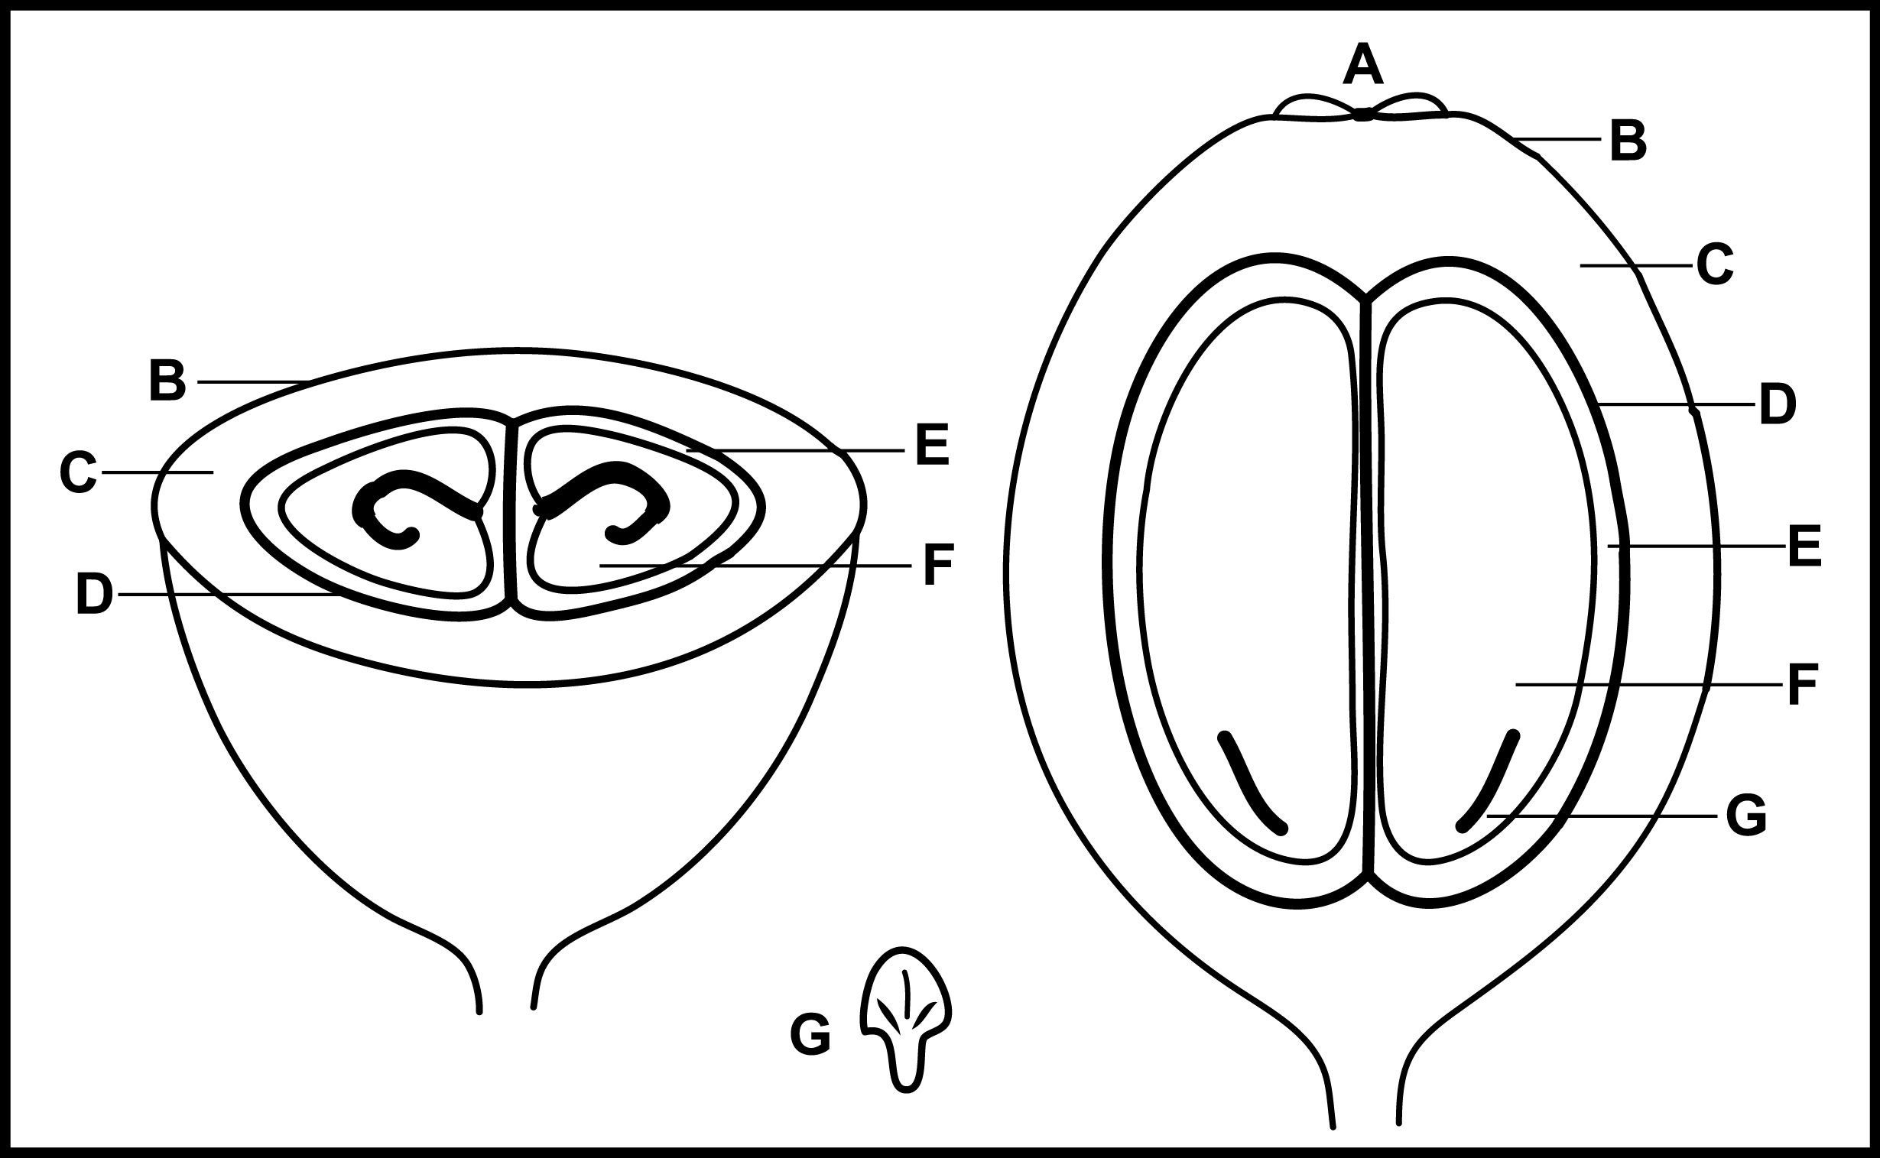

**Processing**

* Washed / Wet-process
* Semi-Washed
  + Honey (Costa Rica)
  + Pulped Natural (Brazil)
* Wet Hulled / Giling Basah (Sumatra)
* Natural / Dry-process
* Experimental (lactic, etc.)

**Drying**

* Mechanical
  + Quick drying for high volume
* Sun
  + Raised bed (Africa)
    - More air circulation
  + Patio (Central/South America)

Sun-dried Coffee should be raked at least once a day for a minimum of 6-8 days.

Ideal drying time is slower, around 20 days!

Coffee is dried to a target moisture range to minimize the risk of fungal and bacterial growth. Moisture content over 13% increases susceptibility.

**Resting**

* Coffee will rest in parchment for ______________ ______________, usually in super sacks or silos

**Milling & Grading**

* Removes and sifts parchment, also called husk or “pergamino” (Spanish)
* Separated by density on Oliver tables and screen size with large screens
* Visual defects are picked out by hand or with a color sorting machine
* Grade is determined by both ____________ _______________ and ________ __________ ( __________ )

**Processing Risks**

* Over-fermentation
* Absorbing negative flavors
* Mold
* Exhaust and other taints

**Cup Defects**

Earthy

* Soily, mineral

Musty

* Mold/mildew, old damp paper, basement

Grassy

* Freshly mowed lawn

Leathery

* Tanned animal hide

Fermented

* Overly sour, alcohol, vinegar, high acetic acid

Phenolic

* Iodine, chemical

**Futures Markets**

* Financial exchange based on supply and demand
* Main uses are setting prices and hedging
* Allows roasters to buy specific weights of coffee at a specified price within a specified future delivery period
* New York
  + Arabica (usc/lb)
  + Contract is 37,500 lb
* London
  + Robusta (USD/MT)
  + Contract is 10 tonnes
* Check market levels at barchart.com under Soft Commodities
* Used by roasters, importers, exporters, co-ops, also financial speculators
* Differential is an amount added or subtracted from the market level based on quality and origin

**Bags & Weights**

* Bag sizes can vary from 30Kg to 21 tons
* From vacuum-packed boxes to bulk container liners
* Traditionally shipped in burlap, jute, hessian, sisal fiber bags
* Specialty exporters typically use Grainpro or Ecotact liners
* Usually __________ in Brazil, Africa and Asia
* Usually __________ in Central and South America
* Colombia uses __________ bags
* Shipping through ocean freight (sea vessel) is how the majority of coffee is transported

**Aging**

* Old coffee can taste “baggy”
* Paper, Cardboard, or Woody
* Many cuppers use the term “__________”
* “Past Crop”

**Storage**

* Ideal temperature range ______ to ______°F
* ______ to ______% relative humidity
* Pay close attention to moisture
* Too little humidity can dry out the green coffee and impact roasting
* Too much humidity could cause mold growth
* Green coffee is porous and will easily absorb aromas such as exhaust in a busy loading dock
* GrainPro or Ecotact bags help protect and maintain freshness for extended periods

**Certifications**

* Focus on socio-economic and environmental factors
  + Organic
  + Fair Trade
  + Rainforest Alliance (now merged with UTZ)
  + 4C
  + Bird Friendly
* May or may not have a ____________ focus
* Typically involve a minimum price or set premium
* Producers are _______________ for compliance to standards

**Traceability**

* Documentation to verify the origin
* Importer Security Filing is required by US Customs & Border Protection
* ICO Marks
* Lot numbers

**Decaffeination**

* Caffeine is a bitter alkaloid and stimulant
* Decaffeination processes involve steaming or soaking green coffee in a solvent to extract caffeine

|  |  |
| --- | --- |
| Chemical | Non-Chemical |
| * Methylene chloride (Dichloromethane) * Ethyl acetate | * Water (Swiss or Mountain) * Carbon dioxide (CO2) |

* US standard requires 97% caffeine removal
* EU standard is 99.9% caffeine-free by mass
* Impacts the flavor, aftertaste, body, and acidity

**Grading Screens**

* Up to ________% under is acceptable
* Example: a sample labeled “Scr 15+” really means at least 90% above screen 15

**Moisture Meter**

* As a roaster, this is essential
* Level specified by ICO Resolution 420 should be ________ - ________%
* Standard range for specialty coffee is ________ - ________%
* The percentage is the level of humidity, NOT the same as water activity
* The Coffee Pro Moisture Mac model has an accuracy of +/- 0.5%
* Note different devices have different specifications